Lab – 4 – Lxd Containers and Ansible
Note: You need to submit screenshots for this lab.
Paste screenshots for each step you performed including all configuration files and Playbooks, etc.

Launching CentOS VM for this Lab:

- Create a new VM from the ubuntu image. (Attach a screenshot)
- Name the VM as “yourname-Ansible”. Power on the VM.
- Open the terminal and log in to VM with
User ID: “Yourname” and use the password “Devops”.
- Get the IP address of the VM and access the machine using Putty.
- Add a new user named “ansible”, set the password as “Devops”, add it to root group, reboot machine, and log in with user credentials. Perform entire lab with newly created VM user.
- Change the Hostname of VM to “<yourname>-ansible”.
{Output - ansible@Yourname-ansible: ~$)
- Upgrade and update your host.
- Install curl on your machine. (Attach a screenshot showing curl installed)

PART 1 – Task: Linux Containers:
- To get started with Linux containers, we need to install the LXD package related to it first, download, and install a package using the following command.
sudo snap install lxd --channel=4.0/stable
- Now we will add the user to the LXD group for management purposes. sudo adduser ansible lxd

- Reboot the machine so that changes will get applied immediately. And verify membership details with the id command: id
Test it with the lxc command: lxc list
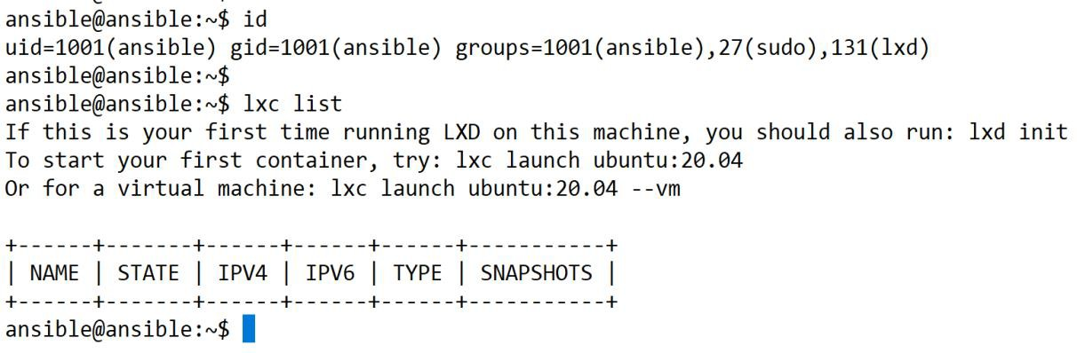

- Before we can start creating containers, we need to tell LXD a little bit about our storage and network needs. (Use the attached ss to answer any questions asked).
Run command: lxd init

Trust password for new clients: Devops Again: Devops
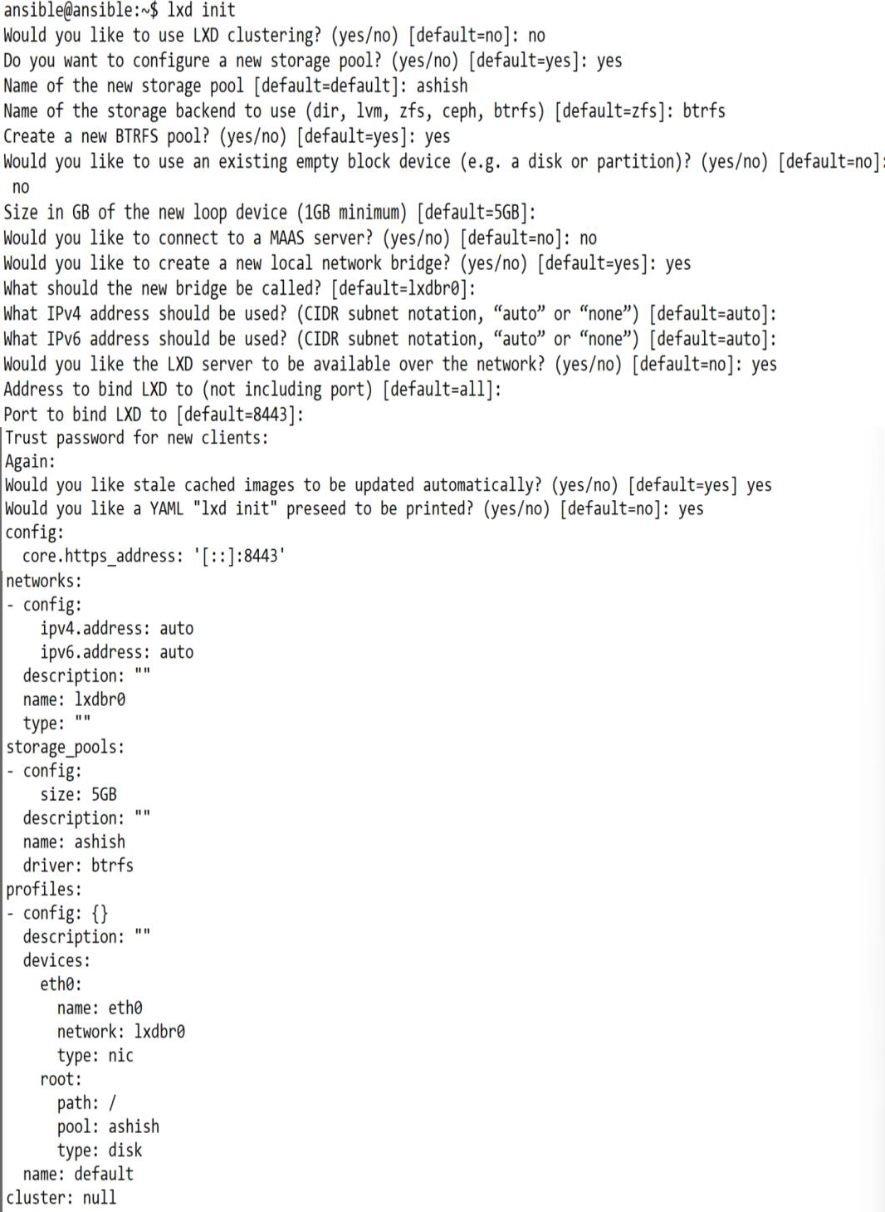

- Let’s launch Ubuntu and centos containers by issuing the following commands sudo lxc launch ubuntu:18.04 <yourname>-ubuntu-container
sudo lxc launch images:centos/7/amd64 <yourname>-centos-container

- List the available images using the command ‘lxc image list’ and list the currently running containers using the command ‘lxc list’.
Paste a screenshot of both commands. Containers should be running.

- To access the shell of a container you can use the following command: lxc exec <container-name/ID> -- /bin/bash
You can use ‘sh’ instead of /bin/bash if bash is not installed by default.
Launch the shell of the ubuntu and centos containers you created and provide the output. (Paste screenshots) of the following:
Current working directory IP address information Current utilization
- Stop the containers you have created. Delete both the containers you created.
Paste a screenshot of the ‘lxc list’ Before & after deleting the containers.
Task: Launch Web Server inside a Container
- Launch a container using the ubuntu 18.04 image and name it as ‘<your-name>-web’

- Login to the shell and then update and upgrade your container
- Install Nginx

- Edit the default index file inside the container, located at /var/www/html/index.nginx- debian.html Make the following changes to the file, also mention your name in the script.
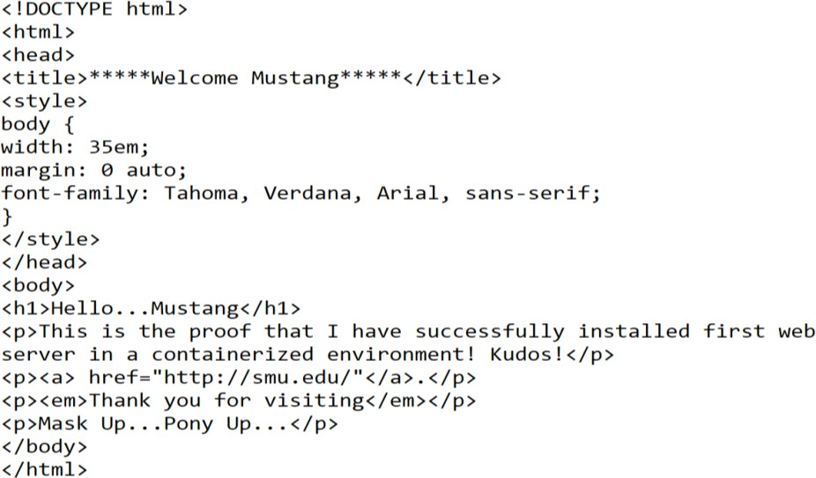

- Restart the Nginx server and find the container's IP address. Then verify the webpage you just created by accessing the URL from a web browser. (Use your container’s IP)

- Exit from the container’s shell and take a snapshot of your container and name it as ‘<your- name>-web-1.0’.
Use command ‘lxc snapshot <containername> <your-name>-Web-1.0’.
- Verify whether the snapshot was created or not.

- Add the following line at the end in the index file of your web container and restart Nginx.
<p>Version 1.1</p>
- Verify the change by reloading the web page.

- Create a new snapshot and name it ‘your-name’-web-1.1

- List the 2 snapshots you created; snapshot names are expected to be seen.

- Restore your container to ‘your-name’-web-1.0 and reload the page to see the webpage going back to the previous stage.

- Delete the latest snapshot you created and verify the same.

- Delete all containers you created till now.

PART 2
Ansible is an open-source automation platform. It is a management tool built in Python. Ansible is a straightforward, powerful, and agentless tool. Ansible scripts are written in YAML.
In Ansible, "ssh" is used to connect to client/target machines.

Ansible Installation:
- Let’s update your system and install ansible. sudo apt-get update -y
sudo apt-get install software-properties-common -y sudo apt-get install python3 -y
sudo apt-get install ansible -y
- Verify installation by running commands: sudo apt list ansible
ansible --version
- Now issue ‘which ansible’ and provide the output

- Using Linux container, run 2 containers called 'ansible-target1' and 'ansible-target2' based on ubuntu:18.04 image.
These containers will be our target machines which we will control using ansible. Access the shell of containers and note down their IP address.
- To manage target machines using ansible, target machines need to have ‘ssh’ and ‘python3’ installed. Install ‘ssh’ and ‘python3’ on both target containers and provide proof for the same.

- Issue the following commands to enable password key-based login ssh-keygen -t rsa (Check attached snapshot for reference)
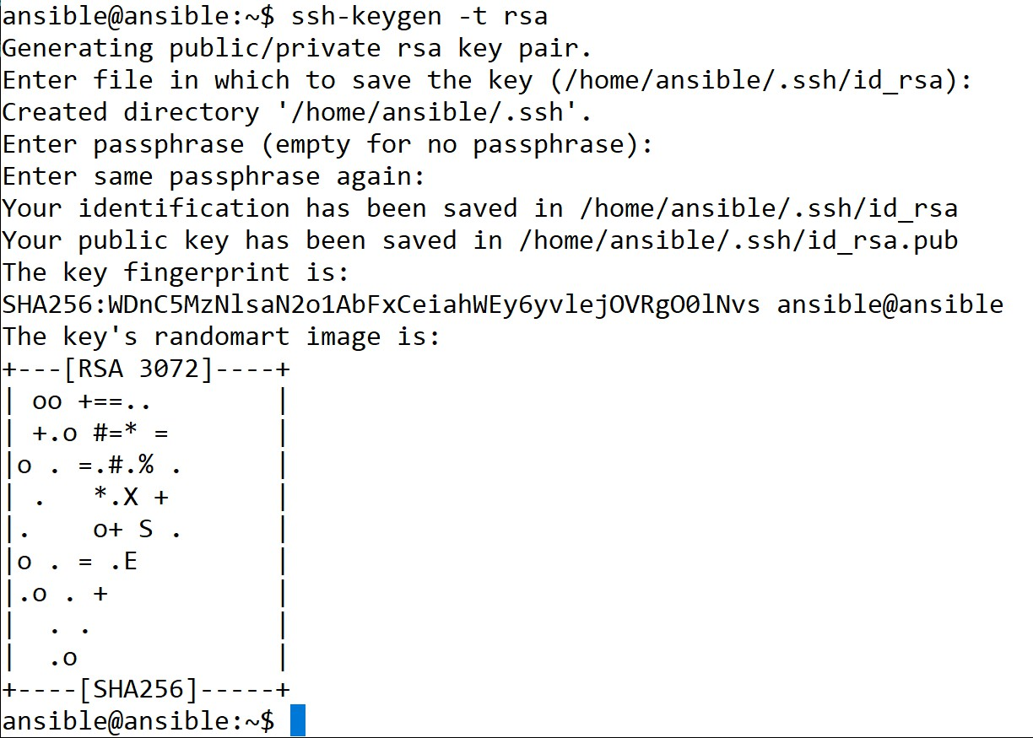
- Change the root user’s (inside the container) password to “Devops”. (Perform this for both containers)
- Edit the ‘sshd_config’ file from both containers as given below: nano /etc/ssh/sshd_config
PermitRootLogin prohibit-password to PermitRootLogin yes PasswordAuthentication no to PasswordAuthentication yes
And then, restart the ssh service: service ssh restart

- Copy the above key into your both target machine’s authorized_keys file located at ‘.ssh/authorized_keys’. To do this run command:
sudo scp .ssh/id_rsa.pub <container-ip>:.ssh/authorized_keys

- Create a directory named ‘<yourname>’ and navigate to it.
- Create an inventory file named ‘inventory’ and edit it as shown in the following snapshot. Add the IP Addresses of both containers in ‘webservers’ group.
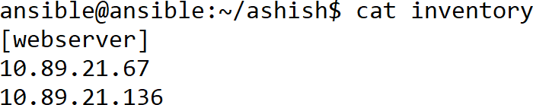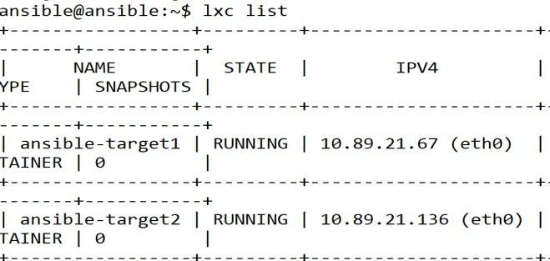

- Ansible Ad-Hoc commands:
ansible ‘container-IP’ -m ping -u root -i inventory You should see an output as shown below
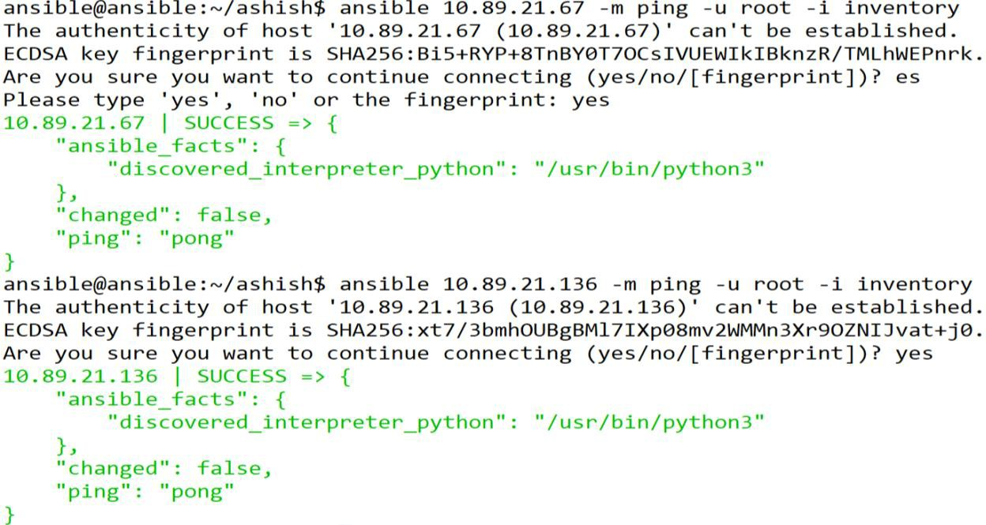

This shows our ansible installation setup is successful. Let’s proceed to perform some tasks now.

PART 3 – Ansible Ad-Hoc Commands:
In this part, you will be using Ansible Ad-Hoc commands. They are just to learn how ansible works. There is no automation involved in Ad-Hoc commands. There is no need to make a script (playbook) to run Ad-Hoc commands. Whenever you want to execute any task only once, you can use them. But if you want to execute any task multiple times, then it is not advised to use them. In such cases, you can use Ansible Playbooks.
- Create 3 more containers using the same ubuntu image and name them APP1, APP2, and DB.
- What are Ansible Modules? List at least 7 ansible modules.
- Install ‘python’ and ‘ssh’ in the newly created containers. Add your host’s ssh key into the target machines (Containers).
Note: Don’t forget to perform steps #8 and #9 from Part 2 before adding SSH keys to containers.

- Edit the inventory file and add the APP1 and APP2 container’s IP in a new group called ‘application’ and the DB IP address in a group called ‘database’. Also, add their IPs in the default group ‘web servers’
- Paste the output of the ansible ad-hoc ping command to ping web servers, applications, and databases separately. You should get success messages.
- Paste the output of the ansible Ad-Hoc command to update the cache and upgrade the ‘database’ container.
- RUN Ansible ad-hoc command on the ‘application’ group which creates a user with ‘yourname’ having the primary group as root. Set password as ‘Devops.
- RUN Ansible ad-hoc command on ‘application’ which creates a file ‘SMU’ on the location ‘/opt’ and the file should have read, write, execute permission to Owner (user) and Group, and only read permission to Others.
- RUN Ansible ad-hoc command on ‘database’ which installs ‘apache2’ and starts its service.
- RUN ansible Ad-Hoc command on ‘database’ to gather facts.
- Run Ansible ad-hoc command on all containers which will return the amount of free memory (command to see free memory is ‘free m’). Your output should look as shown below.
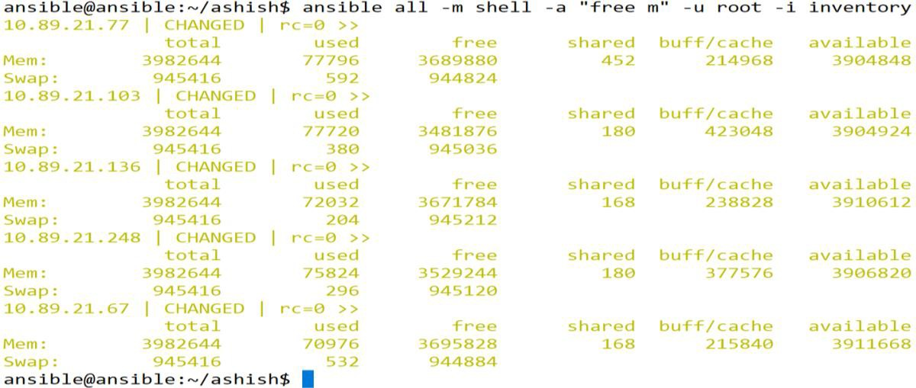

PART 4 – Ansible Playbooks:
Ansible Playbook is a text file written in YAML format and it is saved with the ‘.yml’ or’.yaml’ extension. Playbooks are written once and can be used multiple times. They are idempotent.
Play: A play is an ordered set of tasks run against hosts selected from the inventory. A play can have single or multiple tasks.

Playbook: A playbook is a text file containing a list of one or more plays to run in a specific order.
- Below is a sample playbook format to install the Nginx package. (This task is just for your understanding purpose).

Playbook:
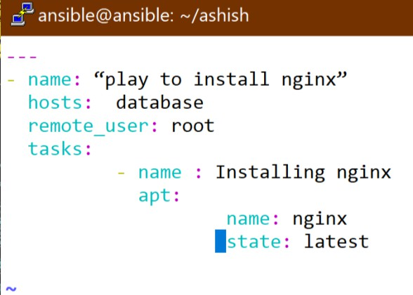

Playbook Execution:
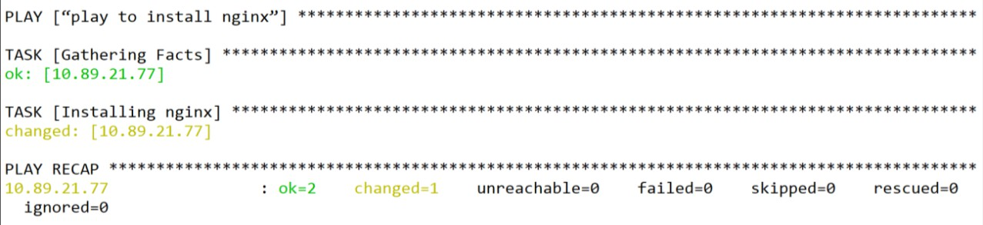

IMPORTANT:

Till this point, you were providing inventory files separately while executing the Ad-Hoc command or running the ansible-playbook. Add your inventory file to Ansible’s configuration file (ansible.cfg), so that you won’t need to provide it each time. To do this you need to copy the content of the ‘inventory’ file from ‘<yourname>’ directory and paste it to ‘/etc/ansible/hosts’.
sudo nano /etc/ansible/hosts (Go through it, to understand how inventory or hosts file is written). sudo cp /home/ansible/<yourname>/inventory /etc/ansible/hosts

- Create a Playbook named ‘firstplaybook.yml’ to install and start Nginx. It should also install init scripts, Ip route, MySQL on APP1 and APP2 containers, and MariaDB-server on DB container.
Paste screenshots of the playbook, command, and output after running the playbook.
- Create a playbook named ‘secondplaybook.yml’ to add three users John, Michael, and Peter to only ‘APP1 container from application group’. Use Ansible Loops in this playbook.
Paste screenshots of a playbook, the command used to run it, and its output after running the playbook.
- Create a playbook named ‘thirdplaybook.yml’ to compress data from the containers ‘/var/log’ directory into the ‘ansible’ users (from Ansible host) home directory. Playbook must have Ansible variables for compression format, compression source path, and compression file destination.
Paste screenshots of a playbook, the command used to run it, and its output after running the playbook.

- Create a playbook named ‘fourthplaybook.yml’ to install and start ‘FTP’ on the application group. Encrypt this playbook using Ansible Vault.
Check its content after encryption using the ‘cat fourthplaybook.yml’ command. Are you able to see exactly what was written in it? If not, then how will you check its content?
Once done, run this encrypted playbook on both containers from the ‘application’ group in such a way that Playbook will not get executed on both at the same time, it should run on 2 containers in one after another manner (Use Parallelism in Ansible).
Paste screenshots of a playbook, various commands used here, and their outputs.

End of Lab

